

Leave
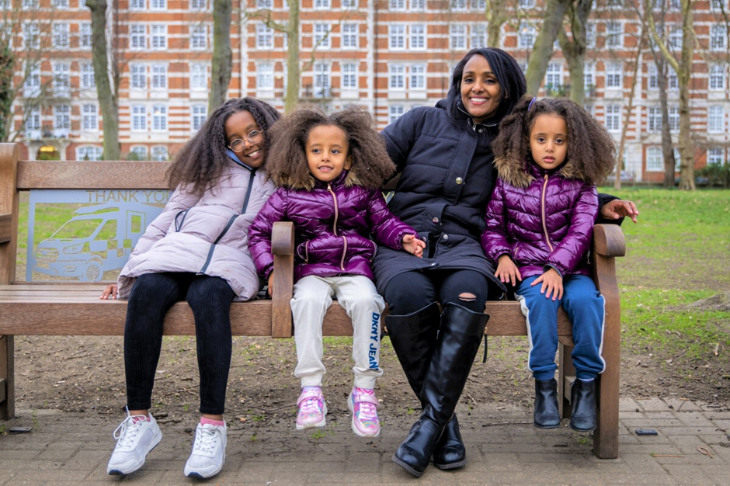


We prioritise kindness

We inspire growth

We achieve together

Home-Start Network
Equity, Equality, Diversity and Inclusion Policy

Title |  | Date
Author | Tanya Samuels | 18/04/24
Approver | Director of Network Impact and SLT | 1/05/24
Owner | Quality Manager
Published | Location of published document @Home June 2024 | 01/06/24
Review frequency | Three years or following significant legislative changes | 01/06/27
Next publication date |  | 06/27

This policy and its associated appendices was adopted by Home-Start Butser on 28 November 2024 and is to be reviewed by November 2027.

Name: Fiona Smart
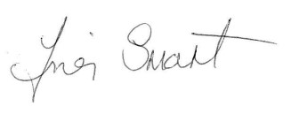

Signed:

Date: 28 November 2024

Introduction

Home-Start Butser is here to support all families with young children through their challenging times. To do this, we need to strive to be the most inclusive organisation we can be. Home-Start Butser want to create an environment where every family, volunteer and staff member, supporter and funder feels welcomed, included and valued.

Scope and Responsibilities

This policy applies to all people who are involved with this service including trustees, staff and volunteers.
The Trustees are aware of their responsibilities under the Equality Act 2010 and will uphold this policy and commit to supporting trustees, staff and volunteers to undertake regular EEDI training, development or updates.

Our Commitment to you

This policy sets outs Home-Start Butser commitment to:
- Respect diversity and progress equality as an employer
- Create an inclusive culture that values diversity
- Take positive action to challenge racism and discrimination

Home-Start Butser believe that a culture of equality, diversity and inclusion not only benefits our organisation but supports staff and volunteer wellbeing which has a positive impact on the service we offer. People who feel comfortable to be themselves contribute to building an inclusive culture for families using the service and volunteers.
We are committed to promoting a service based on dignity, trust and respect, and one that is free from discrimination, harassment, bullying or victimisation.
We ensure that our recruitment, career development and retention procedures for staff and training, support or development opportunities for volunteers do not treat people less favourably because of their:
- disability
- gender, gender identity or gender reassignment status
- marital status
- race, racial group, ethnic or national origin, or nationality
- religion or belief
- sexual orientation
- age
- civil partnership status
- pregnancy or maternity
- paternity
- educational background
- socio-economic background
- caring responsibilities
- part-time status; or
- fixed-term status

What we expect from you

All those representing Home-Start should take personal responsibility for observing, upholding, promoting and applying this policy. Home Start Butser culture is made in the day-to-day interactions between us, so creating the right environment is a responsibility that we all share.
People should treat others who they interact with in their role fairly and with dignity, trust and respect. Sometimes, this may mean allowing for different views and viewpoints and making space for others to contribute. We will support staff and volunteers who in the course of their work or volunteering feel that the values/culture of this policy have been challenged.
We will take appropriate action to address unacceptable behaviour such as discrimination, bullying, harassment and victimisation, through our relevant policies (Grievances, Disciplinary, Whistleblowing and Complaints). All concerns and complaints will be taken seriously, promptly and thoroughly investigated and dealt with sensitively.

Accessible and Inclusive
At Home- Start Butser accessibility is all about designing an experience to meet the needs of everyone, including those with disabilities. We try to ensure that everyone has the same access and that no one is excluded.
Inclusiveness, or the practice of inclusivity, is creating a service which is mindful of a broad range of users, their variable abilities, their variety of environments, situations, and contexts.
For us, inclusive design is all about empathising. It means depicting all types of diversity in our imagery to ensure that we're representing a wider demographic of people with regards to ethnicity, ability, gender and sexual orientation. This helps people to relate to the content by picturing themselves within it.

Discrimination

The Equality Act 2010 prohibits discrimination because of certain protected characteristics. These are:
- disability
- sex
- gender reassignment
- marital or civil partnership status
- race
- religion or belief
- sexual orientation
- age and
- pregnancy or maternity

Discrimination can be intentional or unintentional and may occur directly, indirectly, by association, or by perception (see Appendix A for Different types of discrimination under the Equality Act 2010). We acknowledge that some forms of discrimination may occur in particular settings or environments and due to the close nature of the work discrimination may happen in the confines of a family home.
Discrimination is not always obvious and can be subtle and unconscious. This stems from a person's general assumptions about the abilities, interests and characteristics of a particular group that influences how they treat those people (known as "unconscious bias"). Such assumptions or prejudices may cause them to apply requirements or conditions that put those in particular groups at a disadvantage.

Harassment and sexual harassment
Harassment is unwanted conduct related to a protected characteristic that has the purpose or effect of:
- violating someone else's dignity or
- creating an intimidating, hostile, degrading, humiliating or offensive environment for someone else.

Sexual harassment is:
- conduct of a sexual nature that has the purpose or effect of violating someone's dignity, or creating an intimidating, hostile, degrading, humiliating or offensive environment; and
- less favourable treatment related to sex or gender reassignment that occurs because of a rejection of, or submission to, sexual conduct

You should refer to our Anti-harassment and anti-bullying policy or complaints policy for further information on our procedure for reporting harassment.

Victimisation

Victimisation is treating another person detrimentally either because that person has raised a concern or made a complaint of discrimination or harassment, or because they have supported someone else who has made such a complaint, for example by giving a witness statement that supports the allegations.

Bullying
There is no legal definition of bullying. However, we regard it as conduct that is offensive, intimidating, malicious, insulting, or an abuse or misuse of power, and usually persistent, that has the effect of undermining, humiliating or injuring the recipient.
Bullying can be physical, verbal or non-verbal conduct. It is not necessarily face to face and can be done by email, phone calls, online or on social media. Bullying may occur at work or outside work.
If the bullying relates to a person's protected characteristic, it may also constitute harassment and, therefore, will be unlawful (see Harassment).
You should refer to our Anti-harassment and anti-bullying policy for further information on our procedure for reporting bullying.

Forums

We encourage people to join local forums or consider ways to support EEDI for example, local groups or fora such as neuro diversity forums or consider developing mental health champions etc.

Equality of opportunity

Recruitment

We aim to attract staff and volunteers from the widest possible diversity of backgrounds and experiences. We will ensure that recruitment and selection of staff is inclusive, transparent and fair. We aim to recruit a diverse group of volunteers. Home-Start Butser wants to ensure that the service is attractive and welcoming to the local community and that families with different needs and backgrounds have a good experience of the services.
Job descriptions, person specifications and application processes will be reviewed as each vacancy arises to ensure we use every opportunity to enhance diversity in our organisation. Members of staff will have appropriate training and experience to support inclusive recruitment practices.
Role descriptions for volunteers and our approach to promote and recruit volunteers will be reviewed regularly by Home-Start Butser to promote diversity and inclusion. Volunteer role descriptions should be regularly reviewed to ensure they are inclusive and support diversity.
Every decision-maker should challenge themselves, and other members of the recruitment selection panel, to make sure that any stereotypes, unconscious bias or prejudice do not play any part in recruitment decisions. (For further detail please see our recruitment and selection policy). Individuals involved in volunteer recruitment should be aware of stereotypes and unconscious bias and prejudice do not play any part in recruitment decisions.

Personal development

Any decision made relating to a person's promotion or individual development must be free from discrimination.
We ensure that selection criteria and processes for promotion are reviewed on a regular basis so that there is no discriminatory impact on a certain group.

Disability inclusion

Recruiting people with a disability

Home-Start Butser will consider disability in advance of a recruitment campaign so that advertising, application forms and assessments, arrangements for interviews, job descriptions and person specifications, and selection criteria are appropriate and as inclusive as possible.
Applicants attending interview will be asked if they require any reasonable adjustments to be made to the interview stage. These may include ensuring easy access to the premises for an interview/ an alternative to a telephone interview for a deaf candidate/providing a suitable chair for an interview with a candidate suffering from back problems.

Reasonable adjustments

Home-Start Butser will strive, within our means as a charity, to ensure our work is inclusive and accessible in respect of protected characteristics and people’s lived experiences. Where possible, we will make reasonable tailored adjustments to accommodate the diverse needs and requirements of staff and volunteers.
This includes making reasonable adjustments for people who are neurodiverse, also working to make all of our working practices more inclusive from a neurodiversity perspective.
We encourage people with disabilities to let us know so that we can support you, for example by making reasonable adjustments to our premises or to aspects of your role, or to our working practices.

Training
We encourage every current employee, trustee or volunteers to participate in equality, diversity and inclusion training/updates etc. We encourage trustees, staff and volunteers to support our equality, diversity and inclusion initiatives and encourage them to attend events and workshops to inform them the challenges faced by others and how to help alleviate these in the service.

Taking positive action to challenge racism and discrimination

We uphold an ethical and organisational commitment to going beyond the minimum expectations in terms of equality and diversity. We recognise the important role Home-Start Butser has in creating change, modelling positive behaviour, taking action and reporting on progress.
We commit to using our voice as a charity to promote inclusion and challenge discrimination in order to raise awareness and tackle the challenges faced by families experiencing marginalisation and discrimination.
We value lived experience, the ability to draw from one’s lived experience and to bring insights to an organisation and will seek to sensitively support individuals to bring their lived experience into enhancing our impact.
We seek to raise the profile of under-represented groups within all of our materials and public-facing activities, seeking in particular to challenge stereotypes. We will actively promote our work with diverse communities, to reach as many people as we can with our support.

Appendices

Different types of discrimination under the Equality Act 2010
- Direct discrimination: Treating someone less favourably because of a protected characteristic compared with someone who does not have that characteristic (for example choosing not to recruit someone because they are disabled and you think they "wouldn't fit in" to the team).
- Indirect discrimination: Where a policy, procedure or way of working that applies to everyone puts people with a particular protected characteristic at a disadvantage, compared with people who do not have that characteristic, unless there is a good reason to justify it. An example is introducing a requirement for all staff to finish work at 6pm. It is arguable that female employees, who statistically bear the larger share of childcare responsibilities could be at a disadvantage if the new working hours prevent them from collecting their children from school or nursery.
- Associative discrimination: Treating someone less favourably because they are associated with someone who has a protected characteristic, for example because their partner is transgender.
- Discrimination by perception: Treating someone less favourably because you perceive them to have a protected characteristic even if they do not, for example choosing not to promote someone because you mistakenly perceive them to be gay.
- Discrimination arising from disability: Treating someone unfavourably because of something connected with that person's disability and where such treatment is not justified. Examples include:
  - dismissing or failing to pay a bonus to someone because of their disability-related absence; or
  - disciplining someone for losing their temper where such loss of temper was out of character and was due to severe pain caused by them having cancer.
- Failing to make reasonable adjustments: Employers are legally obliged to make reasonable adjustments to ensure that aspects of employment, or the employer's premises, do not put a disabled person at a substantial disadvantage. Failing to comply with this duty is unlawful. Examples of reasonable adjustments might include:
  - allocating some of the disabled person's duties to a colleague;
  - changing their working hours or place of work;
  - adjusting procedures for assessing job candidates; and
  - modifying disciplinary and grievance procedures.

References

Name / Source
Equality Act 2010
Protection from Harassment Act (1997)

Human Rights Act 1998

Data Protection Act 2018
UK General Data Protection Regulation (retained from EU Regulation 2016/679 EU)
Fair Employment and Treatment (Northern Ireland) Order 1998

